**Kubernetes Course**

The major goal of the Kubernetes training is to provide participants with a thorough familiarity with Docker and Kubernetes. Pods, Labels, Volumes, Replication Controllers, Services, and the rest of Kubernetes' essential components are all discussed in detail. Students will gain knowledge of how to set up, administer, and make use of Kubernetes objects via a combination of classroom instruction and practical experience in the lab.

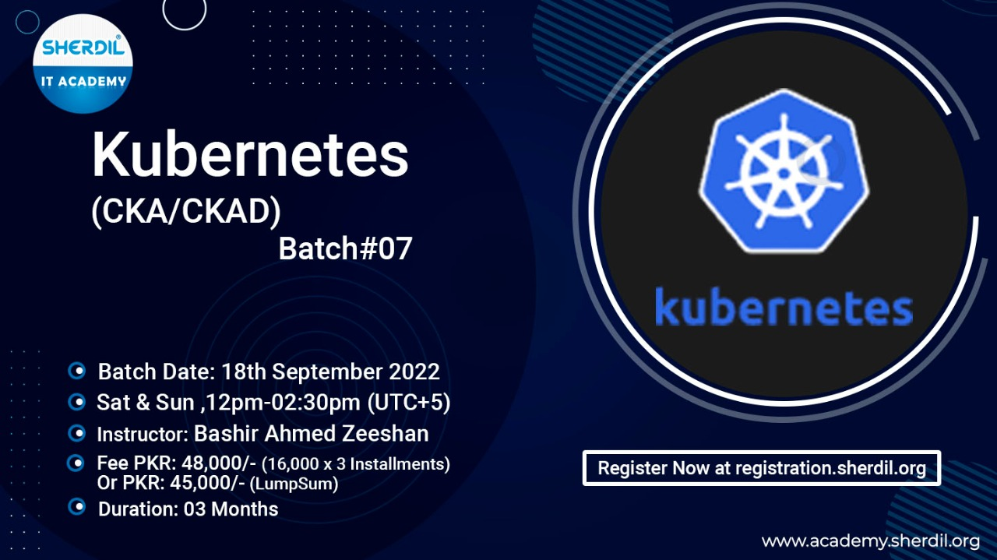

This course is for everyone who want to learn Kubernetes foundation and container orchestration. It will also provide you with the skills for seeking higher-level container expertise via certification programs.

* Developers /Operations
* DevOps Engineers
* IT Project Team
* Students
* Anyone who wants to build a career in Cloud

# Instructor:

[Bashir Ahmed Zeeshan](https://www.linkedin.com/in/bashirahmedzeeshan/), A Technical Training Specialist is a Certified Kubernetes Application Developer (CKAD) and Multi-Cloud Enthusiast with multiple certifications on his badge.

<https://www.linkedin.com/in/bashirahmedzeeshan/>

# Training Content

Here is the curriculum of the course including, but not limited to;

|  |  |  |  |
| --- | --- | --- | --- |
| **Topic** | **Sub-Topic** | **Theory** | **Lab** |
| **Getting started with Kubernetes** | Kubernetes and its importance | ● |  |
| Background & future | ● |  |
| Need of Kubernetes & Big picture | ● |  |
| What is Kubernetes for | ● |  |
|  |  |  |  |
| **Before Kubernetes** | Microservices, What, Why and How | ● |  |
| Containerization and Kubernetes | ● |  |
| Docker and Container Lifecycle | ● | ● |
| Working with Docker images | ● | ● |
|  |  |  |  |
| **Kubernetes Walkthrough** | Architecture of Kubernetes | ● |  |
| Cluster Architecture | ● |  |
| Kubernetes core concepts: | ● | ● |
| Overview of other installations’ options | ● | ● |
| Kubernetes API primitives | ● | ● |
|  |  |  |  |
| **Application Environment, Configuration** | Pods, labels/selectors, replication controllers, services, API | ● | ● |
| Services and other network primitives | ● | ● |
| Deployments, jobs, and services | ● | ● |
| Declarative vs imperative mode | ● | ● |
| Getting Started with YAML | ● | ● |
| Interacting with kubectl | ● | ● |
|  |  |  |  |
| **Observability & Maintenance** | Pods health checks | ● | ● |
| Readiness/Liveness Probe | ● | ● |
| Understand how to monitor applications. | ● | ● |
| Manage application logs. | ● | ● |
| Use label selectors to schedule Pods. |  | ● |
| Understand how resource limits | ● | ● |
|  |  |  |  |
| **Application Deployment & Lifecycle Management** | Understand Deployments and how to perform rolling updates and rollbacks. | ● | ● |
| Know various ways to configure applications. | ● | ● |
| Know how to scale applications. | ● | ● |
| Understand the primitives necessary to create a self-healing application. | ● | ● |
|  |  |  |  |
| **Storage / Persistence** | Understand persistent volumes and know how to create them. | ● | ● |
| Understand access modes for volumes. | ● | ● |
| Understand persistent volume claims primitive. | ● | ● |
| Understand Kubernetes storage objects. | ● | ● |
| Know how to configure applications with persistent storage. | ● | ● |
|  |  |  |  |
| **Services & Networking** | Services Know how | ● |  |
| Understand the networking configuration on the cluster nodes. | ● | ● |
| Understand Pod networking concepts. | ● | ● |
| Understand service networking. | ● | ● |
| Deploy and configure network load balancer. | ● | ● |
| Know how to use Ingress rules. | ● |  |
|  |  |  |  |
| **Troubleshooting Best Practices** | Troubleshoot application failure. |  | ● |
| Troubleshoot control/worker plane failure. |  | ● |
| Troubleshoot networking. |  | ● |
|  |  |  |  |
| **BONUS Topics** | Managed Kubernetes |  | ● |
| Getting Started with Kubernetes on EKS |  | ● |
| Guide to pass CKAD / CKA exam | ● | ● |
|  |  |  |  |

# Format of the boot camp

Part lecture, part discussion, exercises, and lots of hands-on practice.

# Duration & Schedule

Saturday & Sunday (12:30 ~ 03:00 PM PST) 18th September 2022,

# Requirements

* Familiarity with the Linux command line
* An understanding of networking concepts
* Know-how of web applications work
* Docker and Containerization